**ONLINE HELP DESK & GRIEVANCE HANDLING SYSTEM**

**Mini-Project Batch Number-12B13**

**(Ex: 12101)**

A mini-project report submitted in partial fulfillment of the requirement for the award of the degree of **Bachelor of Technology in Information Technology**.

**SUBMITTED BY:-**

**B.Geethika : 12251A1268**

**G.Nikhitha : 12251A1276**

**K.Swapna : 12251A1287**

**R.Sai Sruthi : 12251A12A8**

Under the esteemed guidance of:

**Mrs.P.V.Venkateswaramma**



**Department of Information Technology**

**G. Narayanamma Institute of Technology and Science (for Women)**

Autonomous of JNTUH, Accredited by NAAC of UGC

An ISO 9001-2008 Certified Institution

**Shaikpet, Hyderabad-08**

**July, 2015**



This is to certify that the Mini-project report entitled **“Online Help Desk & Grievance Handling System”** is bonafide work done by

B.Geethika :12251A1268

G.Nikhitha : 12251A1276

K.Swapna : 12251A1287

R.Sai Sruthi : 12251A12A8

under the guidance during 2014 to 2015, in partial fulfillment for the award of degree in”Bachelor of Technology” in Information Technology, from G.Narayanamma Institute of Technology and Science, Autonomous of JNTUH .

Internal Guide Head of the Department

**Mrs.P.V.Venkateswaramma Dr.I.Ravi Prakash Reddy**

Assistant Professor H.O.D

IT DEPT IT DEPT

s



This is to certify that the Min-project report entitled **“Online Help Desk & Grievance Handling System”** that is being submitted by

B.Geethika :12251A1268

G.Nikhitha : 12251A1276

K.Swapna : 12251A1287

R.Sai Sruthi : 12251A12A8

In partial fulfillment for the award of B.Tech in to the G.Narayanamma Institute of Technology and Science is a record of bonafide work carried out by her at our organization/institution

Head of the Department

**Dr.I.Ravi Prakash Reddy**

IT-DEPT

GNITS

**Acknowledgement**

The satisfaction that accompanies the successful completion of any work would be incomplete without naming the people who made it possible,whose constant guidance and encouragement made this work perfect.

We also take it a privilege to thank our beloved Principal **Dr.K.Ramesh Reddy,** for providing us a moral guidance through his speeches and for extending the infrastructural lab and other facilities without which the project could not have been completed successfully.

We respectfully acknowledge **Dr.I.Ravi Prakash Reddy,** Head of Department, Information Technology, all our professors and staff, for their support, encouragement and their advice and guidance.

We are deeply grateful to our Internal project guide **Mrs.P.V.Venkateswaramma,** Assistant Professor,Department of Information Technology for having kindly obliged to take the onus of guiding us for this project.

**ABSTRACT**

Our project Online Help Desk & Grievance Handling System is aimed at developing an Online Help Desk (OHD) for the facilities in the campus. This is an Intranet based application that can be accessed throughout the campus. This system can be used to automate the workflow of service requests for the various facilities in the campus. This is sone integrated system that covers different kinds of facilities like class-rooms, labs, hostels, mess, canteen, computer center & etc. Registered users (students, faculty, lab-assistants and others) will be able to login and can get their queries resolved. These requests will be sent to the concerned people, who are also authenticated users of the system, to get them resolved. Desk Pro is the small step to reduce communication distance between college administration and members of college.

**TABLE OF CONTENTS**

1. INTRODUCTION

1.1 Purpose Of The Project………………………………………....1

* 1. Aims & Objectives……………………………………………..1
  2. Scope Of The Project…………………………………………...1

2. SYSTEM REQUIREMETS

2.1 Hardware Requirements………………………………………...2

* 1. Software Requirements………………………………………....2

3. SYSTEM DESIGN

* 1. Introduction……………………………………………………..3
  2. E-R diagrams……………………………………………………4
  3. UML Diagrams………………………………………………….5
     1. UseCase Diagram…………………………………...5
     2. Class Diagram…………………………...…………..6
     3. Sequence Diagram………………………..…………7
     4. Activity Diagram…………………………….………8

4.Testing

4.1 Introduction………………………………………………….….9

4.2 Testing Strategies…………………………………………….…9

5. SYSTEM IMPLEMENTATION

* 1. System testing(Test cases)……………………………………..13

6. CONCLUSION AND SCOPE…………………………………………..15

7. APPENDIX

7.1 User interfaces………………………………………………….16

7.2 Screens…………………………………………………………17

7.3 Code……………………………………………………………23

8.BIBILOGRAPHY……………………………………………………….54

9.REFERENCES…………………………………………………………..55

**1. INTRODUCTION**

**1.1:Purpose Of Project:**

The main purpose of this project is to put to an end the difficulties of students, faculty encountered in the college. This is actualized by designing computerized ONLINE HELP DESK which is user friendly and interactive. By the time this software is designed and implemented, the problems & queries of college members will be eliminated.

**Significance Of Project:**

With the growth in information technology, the study offers numerous benefits to the students and to any organization that deals on college members problems.This project is very useful to the students,parents,faculty members of the college.

**1.2: Aims And Objectives:**

To develop software called ONLINE HELP DESK that will replace the manual method. To develop, promote, and provide adequate and efficiently ONLINE HELP DESK. To maintain an efficient system of ONLINE HELP DESK admin need to check each and query of each member. To demonstrate increased motivation to the Student Queries

**1.3:Scope Of Project:**

This project work is narrowed to College and its administraion. It deals with the development of ONLINE HELP DESK to help in the checking of college members queries and solve their problems.

**2. SYSTEM REQUIREMENTS**

**2.1 HARDWARE REQUIREMENTS:**

Processor :- Intel core i3

Processor Speed :- 677 MHZ

RAM :- 4GB

Hard Disk Capacity :- 160GB

**2.2 SOFTWARE REQUIREMENTS:**

Programming Languages :- Java, Xml

Operating System :- WINDOWS 7

IDE/Workbench :- My Eclipse 4.4.2

Web Application :- JDBC,Servlets,jsp

Web Server :- Tomcat server

Database :- MySql

**3. SYSTEM DESIGN**

**3.1. Introduction:**

Software design sits at the technical kernel of the software engineering process and is applied regardless of the development paradigm and area of application. Design is the first step in the development phase for any engineered product or system.

The designer’s goal is to produce a model or representation of an entity that will later be built. Beginning, once system requirement have been specified and analyzed, system design is the first of the three technical activities -design, code and test that is required to build and verify software.

The importance can be stated with a single word “Quality”. Design is the place where quality is fostered in software development. Design provides us with representations of software that can assess for quality. Design is the only way that we can accurately translate a customer’s view into a finished software product or system. Software design serves as a foundation for all the software engineering steps that follow. Without a strong design we risk building an unstable system – one that will be difficult to test, one whose quality cannot be assessed until the last stage.

During design, progressive refinement of data structure, program structure, and procedural details are developed reviewed and documented. System design can be viewed from either technical or project management perspective. From the technical point of view, design is comprised of four activities – architectural design, data structure design, interface design and procedural design.

**3.2. E – R Diagrams:**

* + The relation upon the system is structure through a conceptual ER-Diagram, which not only specifies the existential entities but also the standard relations through which the system exists and the cardinalities that are necessary for the system state to continue.
  + The entity Relationship Diagram (ERD) depicts the relationship between the data objects. The ERD is the notation that is used to conduct the date modeling activity the attributes of each data object noted is the ERD can be described resign a data object descriptions.
  + The set of primary components that are identified by the ERD are Data object, Relationships, Attributes and Various types of indicators.

The primary purpose of the ERD is to represent data objects and their relationships.

**3.3. UML DIAGRAMS**

**3.3.1 Use Case Diagram:**

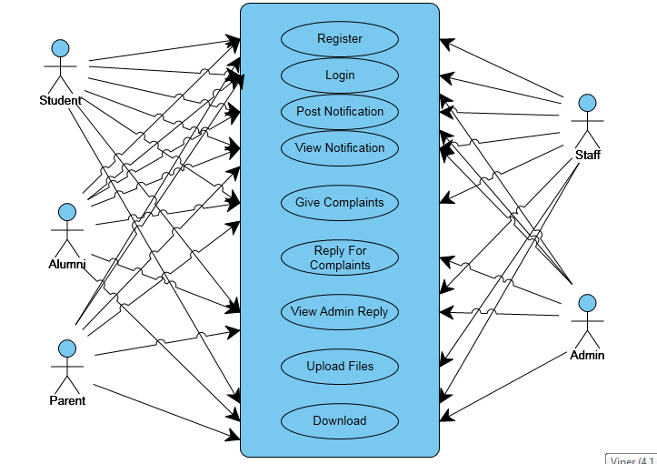

Fig 3.3.1:-Usecase Diagram

**3.3.2 Class Diagram**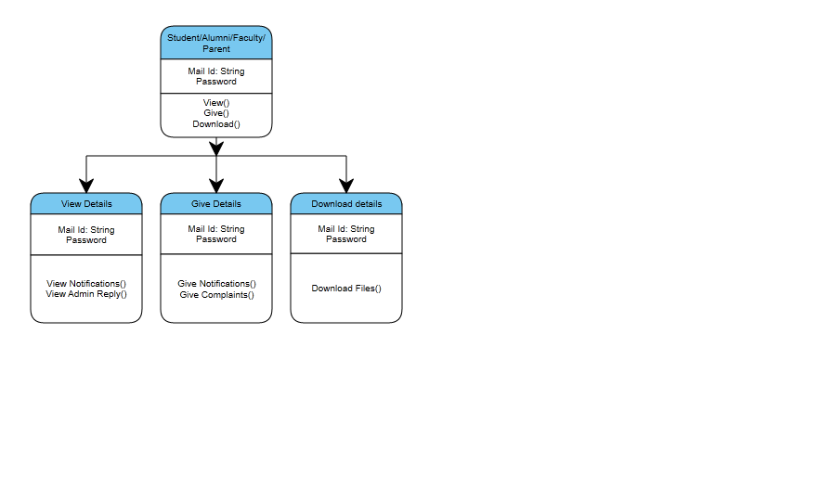

Fig 3.3.2:Class diagram for Student

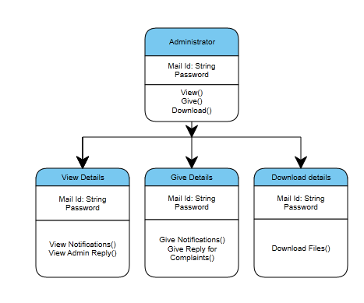

Fig 3.3.2.1:-Class Diagram for Admin

**3.3.3 Sequence Diagram:**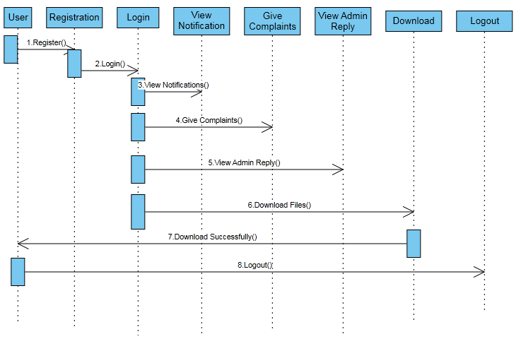

Fig 3.3.3:-Sequence Diagram

**3.3.4 Activity Diagram**

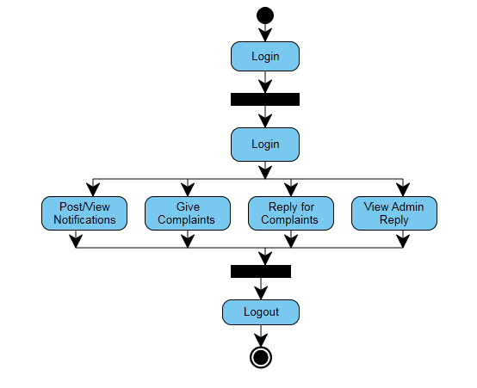

Fig 3.3.4:Activity Diagram

**4. TESTING**

**4.1 Introduction:**

Software testing is a critical element of software quality assurance and represents the ultimate review of specification, design and coding. The increasing visibility of software as a system element and attendant costs associated with a software failure are motivating factors for we planned, through testing. Testing is the process of executing a program with the intent of finding an error. The design of tests for software and other engineered products can be as challenging as the initial design of the product itself.There of basically two types of testing approaches:

**Black-Box testing**:-The specified function that a product has been designed to perform, tests can be conducted that demonstrate each function is fully operated.

**White-Box testing**:-Knowing the internal workings of the product ,tests can be conducted to ensure that the internal operation of the product performs according to specifications and all internal components have been adequately exercised.

White box and Black box testing methods have been used to test this package. The entire loop constructs have been tested for their boundary and intermediate conditions. The test data was designed with a view to check for all the conditions and logical decisions. Error handling has been taken care of by the use of exception handlers.

**4.2 Testing Strategies**:

Testing is a set of activities that can be planned in advanced and conducted systematically. A strategy for software testing must accommodation low-level tests that are necessary to verify that a small source code segment has been correctly implemented as well as high-level tests that validate major system functions against customer requirements.

Software testing is one element of verification and validation. Verification refers to the set of activities that ensure that software correctly implements as specific function. Validation refers to a different set of activities that ensure that the software that has been built is traceable to customer requirements.

The main objective of software is testing to uncover errors. To fulfill this objective, a series of test steps unit, integration, validation and system tests are planned and executed. Each test step is accomplished through a series of systematic test technique that assist in the design of test cases. With each testing step, the level of abstraction with which software is considered is broadened.

Testing is the only way to assure the quality of software and it is an umbrella activity rather than a separate phase. This is an activity to be preformed in parallel with the software effort and one that consists of its own phases of analysis, design, implementation, execution and maintenance.

4.3 Unit Testing

This testing method considers a module as single unit and checks the unit at interfaces and communicates with other modules rather than getting into details at statement level. Here the module will be treated as a black box, which will take some input and generate output. Outputs for a given set of input combination are pre-calculated and are generated by the module.

4.4 System Testing:

Here all the pre tested individual modules will be assembled to create the larger system and tests are carried out at system level to make sure that all modules are working in synchronous with each other. This testing methodology helps in making sure that all modules which are running perfectly when checked individually are also running in cohesion with other modules. For this testing we create test cases to check all modules once and then generated test combinations of test paths throughout the system to make sure that no path is making its way into chaos.

4.5 Integrated Testing:

Testing is a major quality control measure employed during software development. Its basic function is to detect errors. Sub functions when combined may not produce than it is desired. Global data structures can represent the problems. Integrated testing is a systematic technique for constructing the program structure while conducting the tests. To uncover errors that are associated with interfacing the objective is to make unit test modules and built a program structure that has been detected by design. In a non - incremental integration all the modules are combined in advance and the program is tested as a whole. Here errors will appear in an endless loop function. In incremental testing the program is constructed and tested in small segments where the errors are isolated and corrected. Different incremental integration strategies are top – down integration, bottom – up integration, regression testing.

Top-Down Integration Test

Modules are integrated by moving downwards through the control hierarchy beginning with main program. The subordinate modules are incorporated into structure in either a breadth first manner or depth first manner. This process is done in five steps:

* Main control module is used as a test driver and steps are substituted or all modules directly to main program.
* Depending on the integration approach selected subordinate is replaced at a time with actual modules.
* Tests are conducted.
* On completion of each set of tests another stub is replaced with the real module
* Regression testing may be conducted to ensure trha5t new errors have not been introduced.

This process continuous from step 2 until entire program structure is reached. In top down integration strategy decision making occurs at upper levels in the hierarchy and is encountered first. If major control problems do exists early recognitions is essential. If depth first integration is selected a complete function of the software may be implemented and demonstrated.

Some problems occur when processing at low levels in hierarchy is required to adequately test upper level steps to replace low-level modules at the beginning of the top down testing. So no data flows upward in the program structure.

Bottom-Up Integration Test:

It begins construction and testing with atomic modules. As modules are integrated from the bottom up, processing requirement for modules subordinate to a given level is always available and need for stubs is eliminated. The following steps implements this strategy.

* Low-level modules are combined in to clusters that perform a specific software sub function.
* A driver is written to coordinate test case input and output.
* Cluster is tested.
* Drivers are removed and moving upward in program structure combines clusters.

Integration moves upward, the need for separate test driver’s lesions.

If the top levels of program structures are integrated top down, the number of drivers can be reduced substantially and integration of clusters is greatly simplified.

4.6 Regression Testing

Each time a new module is added as a part of integration as the software changes. Regression testing is an actually that helps to ensure changes that do not introduce unintended behavior as additional errors.

Regression testing maybe conducted manually by executing a subset of all test cases or using automated capture play back tools enables the software engineer to capture the test case and results for subsequent playback and compression. The regression suit contains different classes of test cases.

A representative sample to tests that will exercise all software functions.Additional tests that focus on software functions that are likely to be affected by the change.

**5. SYSTEM IMPLEMENTATION**

**5.1 System Testing(Test Cases):**

|  |  |  |  |  |
| --- | --- | --- | --- | --- |
| **S.No** | **Test Cases** | **Expected Output** | **Actual Output** | **Action Status** |
| **1.** | **Admin login page** | **Admin successfully Opened Page.** | **Admin successfully logged in.** | **Successful** |
| **2** | **Student opened login page & perform action** | **Student logged in and also performs action like downloading file may successfull.** | **Student logged in & failed to download file because there is no file that which student tries to download.** | **Failed** |
| **4** | **Allumini opened Registration page** | **Registration page opened successfully.** | **By entering their details in registration was successful.** | **Successful** |
| **5** | **Student opens login page** | **Student opened login page by entering user name & password and login may successful** | **Student failed to login because he enters invalid mail id.** | **Failed** |
| **6** | **Alumini login page and performed some action.** | **Alumini opened login page by entering user name and password and also performs some actions are view/post notifications,give complaints,view admin reply,download files.** | **Alumini login successfully after that performed some actions successfully.** | **Successful** |
| **7** | **Parent opened registration page** | **Parent enters all details & registration may successful** | **Parent failed to register because he did not entered mobile number** | **Failed** |
| **8** | **Staff opened login page and performed some action** | **Staff logged in & performs action like view/post notifications.** | **Student login successfully after that performed some actions successfully** | **Succesful** |
| **9** | **Staff logged in & perform an action** | **Staff loggedin & uploaded a video successfully** | **Staff logged in & failed to upload a video because it’s format is not .flv** | **Failed** |

**6. CONCLUSION AND SCOPE**

**6.1 CONCLUSION**

This Online Help Desk & Grievance Handling System is a small step to reduce the communication distance between the college administration and the students.

As the growing need use of computers and other electronic devices would mean the growing demand on rapid and quick technical support,this system is carefully designed to fit the rapid technical support.This system not only helps to reduce the time of tracking the enquiries and problems traditionally but also improves the quality and quantity of data produced by the system which can lead to more support in decision making.

This system is designed to accomidate future upgrading and development without the need for building a new system to fit the growing needs and demands of the system.

**6.2 SCOPE**

At present Online Help Desk & Grievance Handling System has been developed in English language but it can be developed in any local language so that the person’s using this system can have a greater involvement and ease of understanding the system The project has been currently developed in JAVA, but it can also be developed easily in any language as desired by the developer with his choice of the database.

At present online help desk & grievance handling system is an intranet based approach,in future having this system online means the ability of both technicians and administrator to track and respond to demands of students at any time beyond the boundaries and walls of the college which adds one more advantage in replacing the Paper based style.

**7. APPENDIX**

**7.1 User interface**

The project uses a flat,responsive single sheet HTML.5 Template.Html5 is a core technology markup language of the Internet used for sturcturig and presenting content for the World Wide Web.Its core aims have been to improve the language with support for the latest multimedia while keeping it easily readable by humans and consistently understood by computers and devices.

This single page template has been modified to subsequently incorporate various sections involving the details of admin,student,faculty,alumini,parent.We have used a JavaScript code to be able to create text boxes dynamically as per the user’s preference.Also we have used inline CSS to add special properties to the various div elements.

The HTML document can be accessed by the Apache Tomacat web server that is configured using services.msc option.The servlets are called whenever the buttons on the webpage are pressed.The sevlets used are:

1)*AdminServlets*:- This servlet is used to give reply to complaints given by student,staff,alumini,parent and also can post and view notifications and also delete notifications.

2)*StaffServelt*:- This servlet is used to view complaints,notifications and can post notifications,complaints and upload documents like notes for students,download documents.

3)*AluminiServlet*:- This servlet is used to view complaints,notifications and can post notifications,complaints and upload documents like placement papers for students,download documents.

4)*ParentServlet*:- This servlet is used to view complaints,notifications and can post notifications,complaints.

**7.2 Screens:**

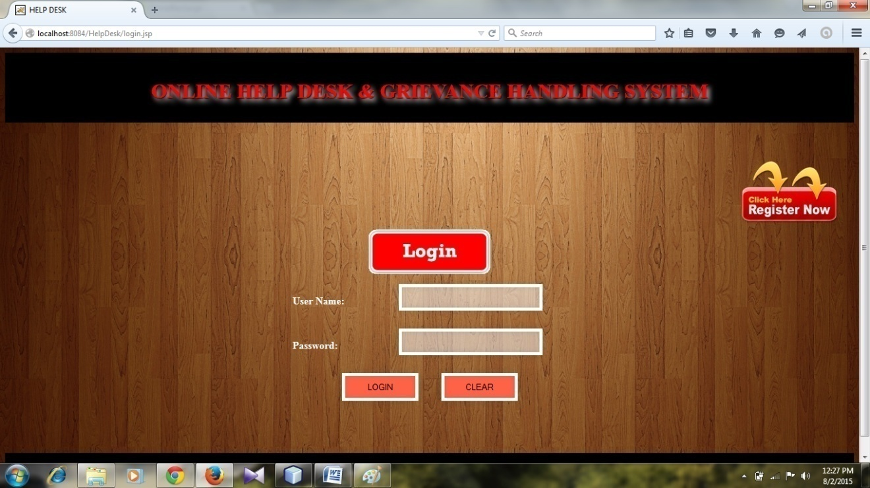

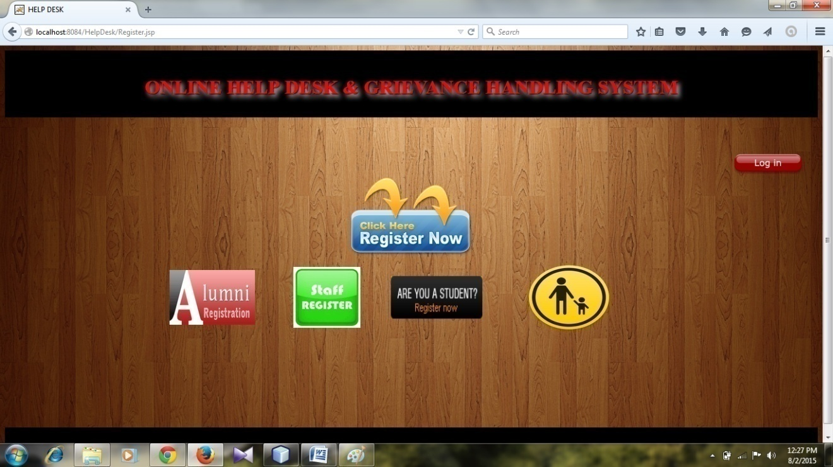

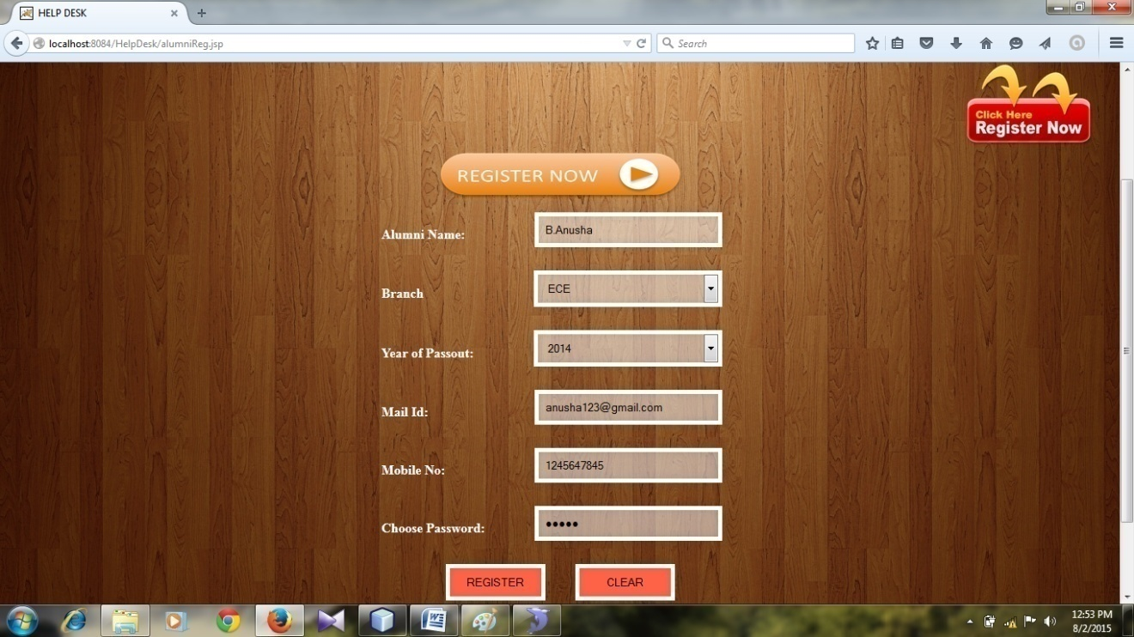

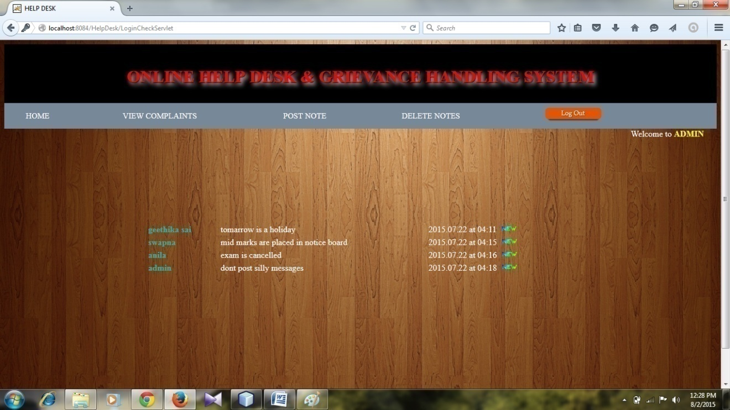

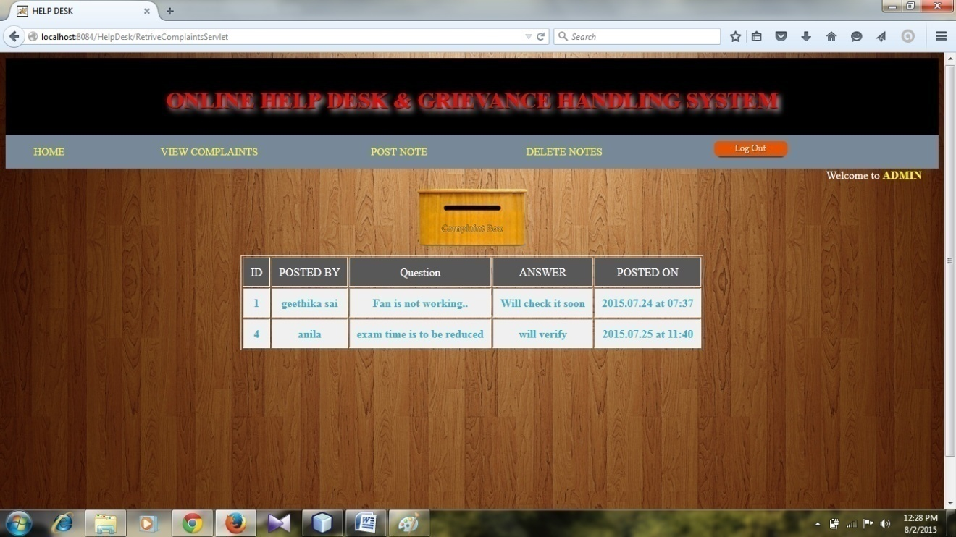

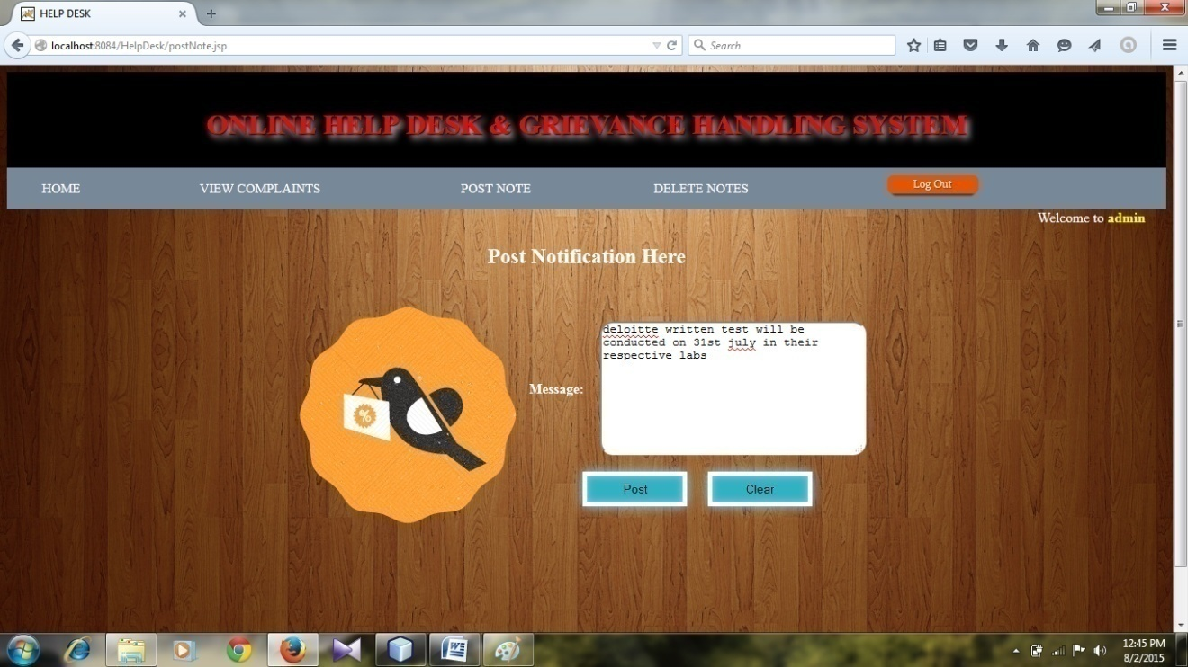

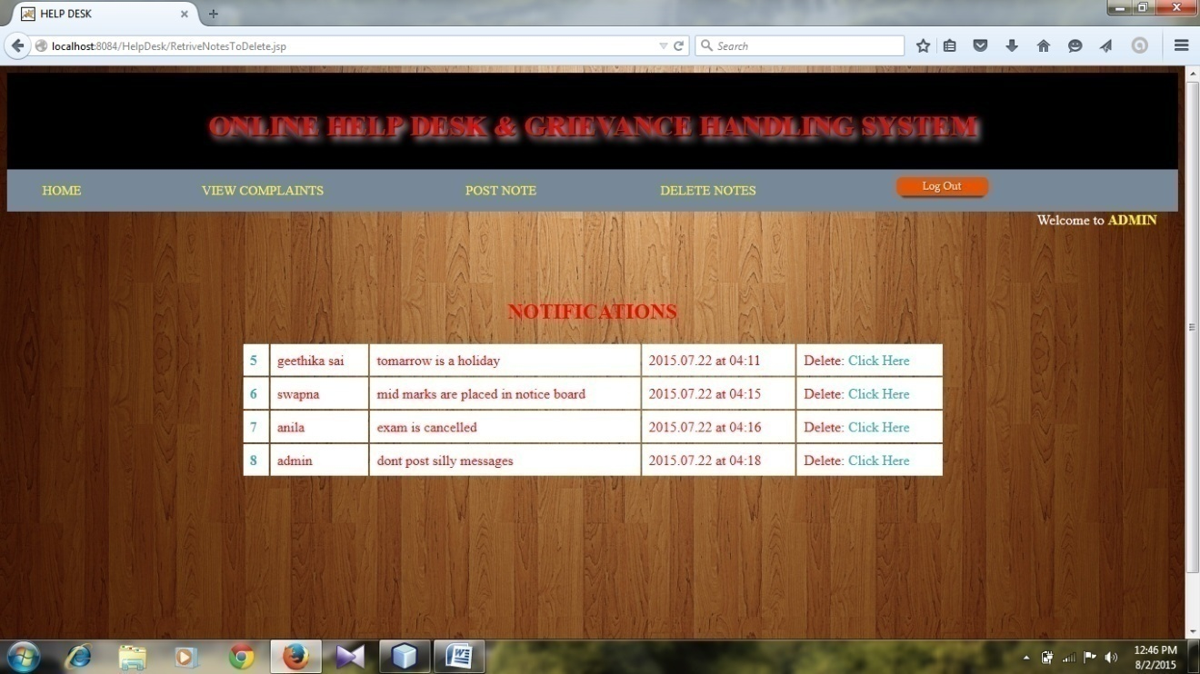

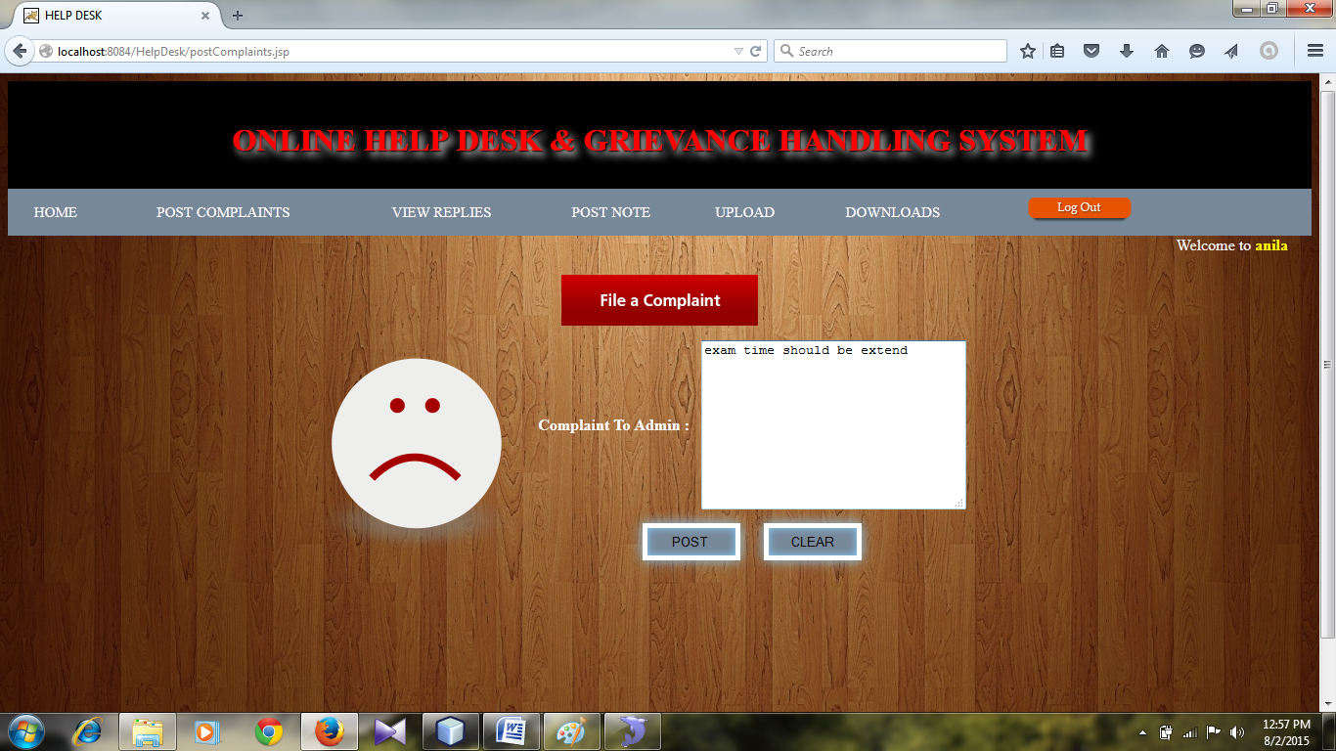

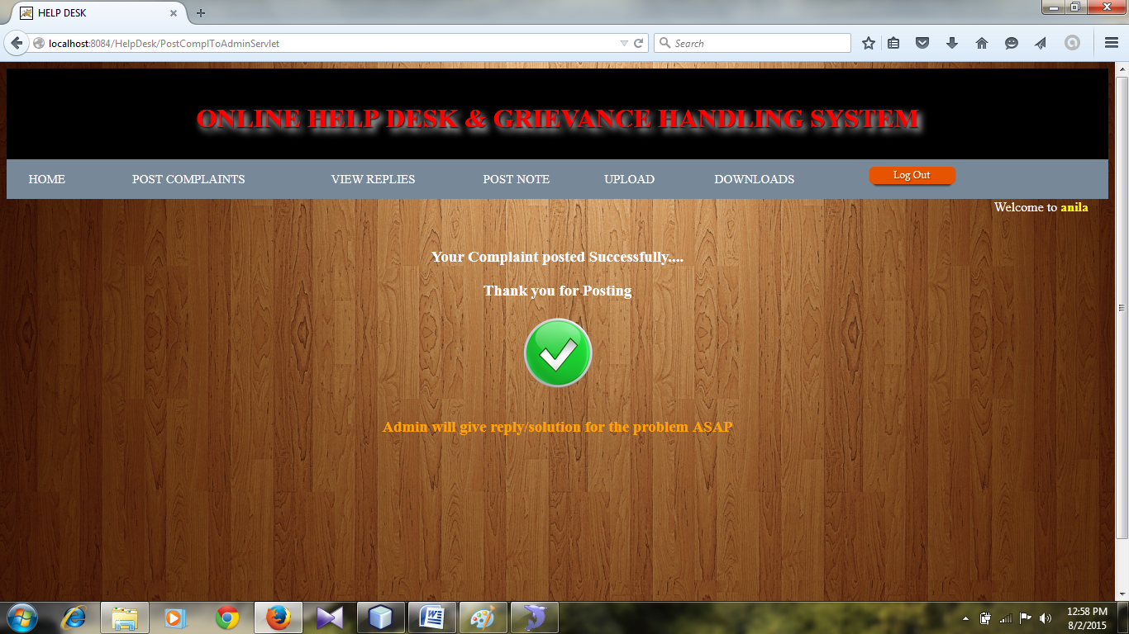

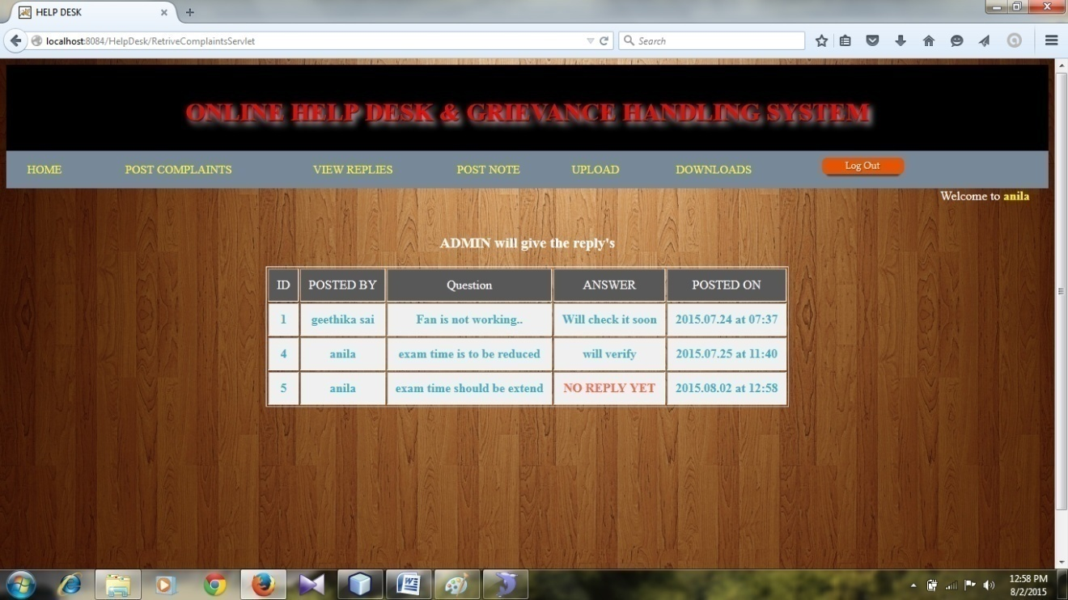

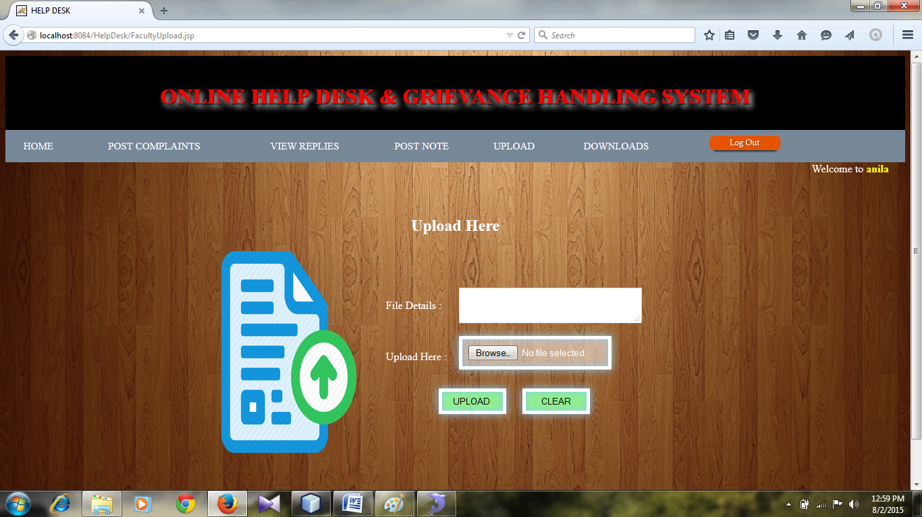

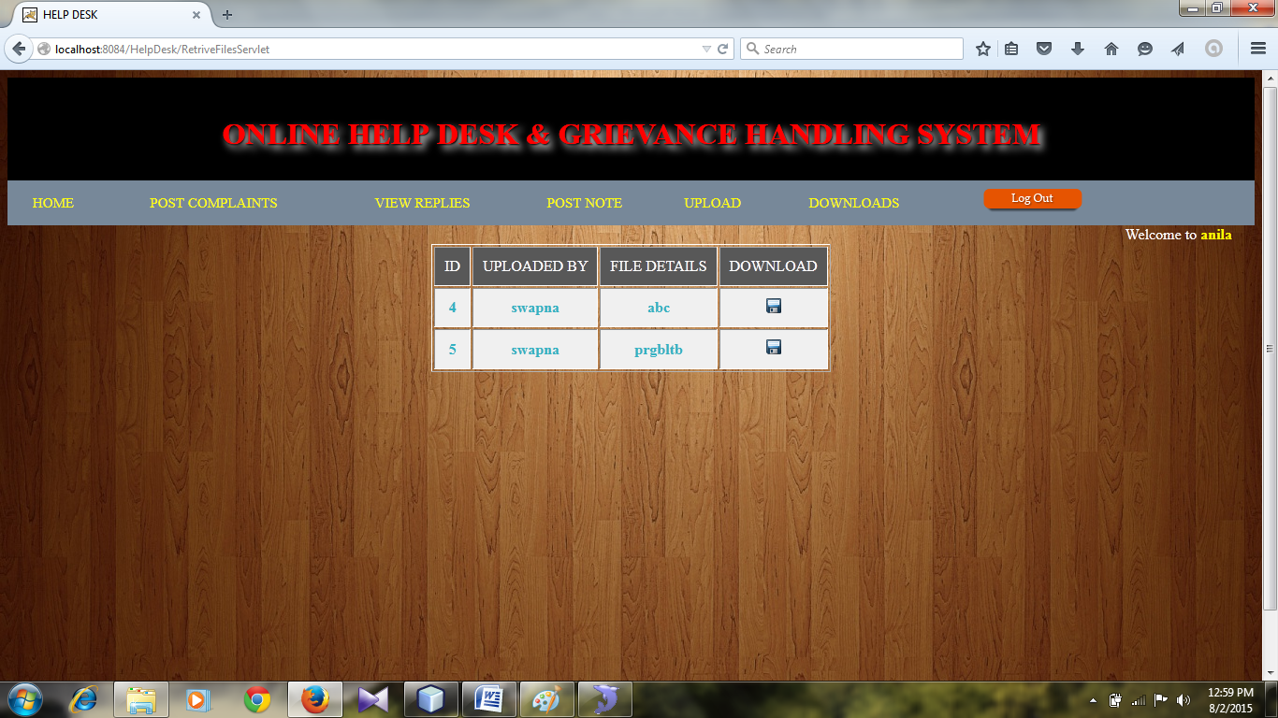

**7.3 Codes:**

**DbConnection.java:**

package com.helpdesk;

import java.sql.*;

public class DbConnection {

static Connection con;

public static Connection getConnections() {

try {

Class.forName("com.mysql.jdbc.Driver");

con = DriverManager.getConnection("jdbc:mysql://localhost:3306/helpdesk","root","root");

} catch (Exception e) {

e.printStackTrace();

}

return con; } }

**PostCmplToAdminServlet.java**

package com.helpdesk;

import java.io.IOException;

import java.io.PrintWriter;

import java.sql.Connection;

import java.sql.PreparedStatement;

import java.text.SimpleDateFormat;

import java.util.Date;

import javax.servlet.RequestDispatcher;

import javax.servlet.ServletException;

import javax.servlet.annotation.WebServlet;

import javax.servlet.http.HttpServlet;

import javax.servlet.http.HttpServletRequest;

import javax.servlet.http.HttpServletResponse;

import javax.servlet.http.HttpSession;

@WebServlet(name = "PostComplToAdminServlet", urlPatterns = {"/PostComplToAdminServlet"})

public class PostComplToAdminServlet extends HttpServlet {

protected void processRequest(HttpServletRequest request, HttpServletResponse response) {

try {

HttpSession session = request.getSession(false);

String name = (String) session.getAttribute("name");

String msg = request.getParameter("msg");

Date dNow = new Date();

SimpleDateFormat ft =new SimpleDateFormat("yyyy.MM.dd 'at' hh:mm");

String dt= ft.format(dNow);

String q = "insert into complaints(comBy,ques,dt) values(?,?,?) ";

Connection con = DbConnection.getConnections();

PreparedStatement pst = con.prepareStatement(q);

pst.setString(1, name);

pst.setString(2, msg);

pst.setString(3, dt);

int i = pst.executeUpdate();

if (i > 0) {

RequestDispatcher dispatcher = request.getRequestDispatcher("ComplaintPostedSuccess.jsp");

dispatcher.forward(request, response);

} else {

RequestDispatcher dispatcher = request.getRequestDispatcher("postingFailed.jsp");

dispatcher.forward(request, response);

}

} catch (Exception e) {

e.printStackTrace();

} finally {

}

}

@Override

protected void doGet(HttpServletRequest request, HttpServletResponse response)

throws ServletException, IOException {

processRequest(request, response);

}

@Override

protected void doPost(HttpServletRequest request, HttpServletResponse response)

throws ServletException, IOException {

processRequest(request, response);

}

@Override

public String getServletInfo() {

return "Short description";

}

}

**RegisterAluminiServlet.java**

package com.helpdesk;

import java.io.IOException;

import java.io.PrintWriter;

import java.sql.Connection;

import java.sql.PreparedStatement;

import javax.servlet.RequestDispatcher;

import javax.servlet.ServletException;

import javax.servlet.annotation.WebServlet;

import javax.servlet.http.HttpServlet;

import javax.servlet.http.HttpServletRequest;

import javax.servlet.http.HttpServletResponse;

@WebServlet(name = "RegisterAlumniServlet", urlPatterns = {"/RegisterAlumniServlet"})

public class RegisterAlumniServlet extends HttpServlet {

protected void processRequest(HttpServletRequest request, HttpServletResponse response) {

try {

String aname = request.getParameter("aname");

String branch = request.getParameter("branch");

String yop = request.getParameter("yop");

String mail = request.getParameter("mail");

String mob = request.getParameter("mob");

String pwd = request.getParameter("pwd");

Connection con = DbConnection.getConnections();

String query = "insert into alumni values(?,?,?,?,?,?)";

PreparedStatement pstmt = con.prepareStatement(query);

pstmt.setString(1, aname);

pstmt.setString(2, branch);

pstmt.setString(3, yop);

pstmt.setString(4, mail);

pstmt.setString(5, mob);

pstmt.setString(6, pwd);

int i = pstmt.executeUpdate();

if (i == 1) {

RequestDispatcher rd = request.getRequestDispatcher("SuccessRegister.jsp");

rd.forward(request, response);

} else {

RequestDispatcher rd = request.getRequestDispatcher("FailureRegister.jsp");

rd.forward(request, response);

}

} catch (Exception e) {

e.printStackTrace();

} finally {

}

}

@Override

protected void doGet(HttpServletRequest request, HttpServletResponse response)

throws ServletException, IOException {

processRequest(request, response);

}

@Override

protected void doPost(HttpServletRequest request, HttpServletResponse response)

throws ServletException, IOException {

processRequest(request, response);

}

@Override

public String getServletInfo() {

return "Short description";

}// </editor-fold>

}

**ReplyByAdminServlet.java**

package com.helpdesk;

import java.io.IOException;

import java.io.PrintWriter;

import java.sql.Connection;

import java.sql.PreparedStatement;

import javax.servlet.RequestDispatcher;

import javax.servlet.ServletException;

import javax.servlet.annotation.WebServlet;

import javax.servlet.http.HttpServlet;

import javax.servlet.http.HttpServletRequest;

import javax.servlet.http.HttpServletResponse;

@WebServlet(name = "ReplyByAdminServlet", urlPatterns = {"/ReplyByAdminServlet"})

public class ReplyByAdminServlet extends HttpServlet {

protected void processRequest(HttpServletRequest request, HttpServletResponse response) {

try {

String question = request.getParameter("question");

String ans = request.getParameter("ans");

String q = "update complaints set ans=? where ques=? ";

Connection con = DbConnection.getConnections();

PreparedStatement pst = con.prepareStatement(q);

pst.setString(1, ans);

pst.setString(2,question);

int i = pst.executeUpdate();

if (i > 0) {

RequestDispatcher dispatcher = request.getRequestDispatcher("AdminSuccessReply.jsp");

dispatcher.forward(request, response);

} else {

RequestDispatcher dispatcher = request.getRequestDispatcher("postingFailed.jsp");

dispatcher.forward(request, response);

}

} catch (Exception e) {

e.printStackTrace();

} finally {

}

}

@Override

protected void doGet(HttpServletRequest request, HttpServletResponse response)

throws ServletException, IOException {

processRequest(request, response);

}

@Override

protected void doPost(HttpServletRequest request, HttpServletResponse response)

throws ServletException, IOException {

processRequest(request, response);

}

@Override

public String getServletInfo() {

return "Short description";

}

}

**RetriveComplaintsServlet.java**

package com.helpdesk;

import java.io.IOException;

import java.io.PrintWriter;

import java.sql.Connection;

import java.sql.PreparedStatement;

import java.sql.ResultSet;

import java.util.ArrayList;

import java.util.HashMap;

import java.util.Map;

import javax.servlet.RequestDispatcher;

import javax.servlet.ServletException;

import javax.servlet.annotation.WebServlet;

import javax.servlet.http.HttpServlet;

import javax.servlet.http.HttpServletRequest;

import javax.servlet.http.HttpServletResponse;

import javax.servlet.http.HttpSession;

@WebServlet(name = "RetriveComplaintsServlet", urlPatterns = {"/RetriveComplaintsServlet"})

public class RetriveComplaintsServlet extends HttpServlet {

protected void processRequest(HttpServletRequest request, HttpServletResponse response) {

try {

HttpSession session = request.getSession(false);

String uname = (String) session.getAttribute("username");

Connection con = DbConnection.getConnections();

String q = "select * from complaints";

PreparedStatement pst = con.prepareStatement(q);

ResultSet rs = pst.executeQuery();

ArrayList al = new ArrayList();

while (rs.next()) {

Map map = new HashMap();

map.put("id", rs.getString("id"));

map.put("comBy", rs.getString("comBy"));

map.put("ques", rs.getString("ques"));

map.put("ans", rs.getString("ans"));

map.put("dt", rs.getString("dt"));

al.add(map);

}

request.setAttribute("list", al);

if (uname.equals("admin")) {

RequestDispatcher rd = request.getRequestDispatcher("ViewComplaintsToAdmin.jsp");

rd.forward(request, response);

} else {

RequestDispatcher rd = request.getRequestDispatcher("ViewComplaints.jsp");

rd.forward(request, response);

}

} catch (Exception e) {

e.printStackTrace();

} finally {

}

}

@Override

protected void doGet(HttpServletRequest request, HttpServletResponse response)

throws ServletException, IOException {

processRequest(request, response);

}

@Override

protected void doPost(HttpServletRequest request, HttpServletResponse response)

throws ServletException, IOException {

processRequest(request, response);

}

@Override

public String getServletInfo() {

return "Short description";

}

}

**RetriveFilesServlet.java**

package com.helpdesk;

import java.io.IOException;

import java.io.PrintWriter;

import java.sql.Connection;

import java.sql.PreparedStatement;

import java.sql.ResultSet;

import java.util.ArrayList;

import java.util.HashMap;

import java.util.Map;

import javax.servlet.RequestDispatcher;

import javax.servlet.ServletException;

import javax.servlet.annotation.WebServlet;

import javax.servlet.http.HttpServlet;

import javax.servlet.http.HttpServletRequest;

import javax.servlet.http.HttpServletResponse;

@WebServlet(name = "RetriveFilesServlet", urlPatterns = {"/RetriveFilesServlet"})

public class RetriveFilesServlet extends HttpServlet {

protected void processRequest(HttpServletRequest request, HttpServletResponse response) {

try {

Connection con = DbConnection.getConnections();

String q = "select * from store";

PreparedStatement pst = con.prepareStatement(q);

ResultSet rs = pst.executeQuery();

ArrayList al = new ArrayList();

while (rs.next()) {

Map map = new HashMap();

map.put("id", rs.getString("id"));

map.put("name", rs.getString("name"));

map.put("details", rs.getString("details"));

map.put("path", rs.getString("path"));

al.add(map);

}

request.setAttribute("list", al);

RequestDispatcher rd = request.getRequestDispatcher("ViewFiles.jsp");

rd.forward(request, response);

} catch (Exception e) {

e.printStackTrace();

} finally {

}

}

@Override

protected void doGet(HttpServletRequest request, HttpServletResponse response)

throws ServletException, IOException {

processRequest(request, response);

}

@Override

protected void doPost(HttpServletRequest request, HttpServletResponse response)

throws ServletException, IOException {

processRequest(request, response);

}

@Override

public String getServletInfo() {

return "Short description";

}

}

**StoreNotificationSrevlet.java**

package com.helpdesk;

import java.io.IOException;

import java.io.PrintWriter;

import java.sql.Connection;

import java.sql.PreparedStatement;

import java.text.SimpleDateFormat;

import java.util.Date;

import javax.servlet.RequestDispatcher;

import javax.servlet.ServletException;

import javax.servlet.annotation.WebServlet;

import javax.servlet.http.HttpServlet;

import javax.servlet.http.HttpServletRequest;

import javax.servlet.http.HttpServletResponse;

import javax.servlet.http.HttpSession;

@WebServlet(name = "StoreNotificationsServlet", urlPatterns = {"/StoreNotificationsServlet"})

public class StoreNotificationsServlet extends HttpServlet {

protected void processRequest(HttpServletRequest request, HttpServletResponse response) {

try {

String msg = request.getParameter("notification");

HttpSession session = request.getSession(false);

String name=(String) session.getAttribute("name");

Date dNow = new Date();

SimpleDateFormat ft =new SimpleDateFormat("yyyy.MM.dd 'at' hh:mm");

String dt= ft.format(dNow);

String q = "insert into notes(postedBy,msg,dt) values(?,?,?) ";

Connection con = DbConnection.getConnections();

PreparedStatement pst = con.prepareStatement(q);

pst.setString(1, name);

pst.setString(2, msg);

pst.setString(3, dt);

int i = pst.executeUpdate();

if (i > 0) {

RequestDispatcher dispatcher = request.getRequestDispatcher("NotePostedSuccessfully.jsp");

dispatcher.forward(request, response);

} else {

RequestDispatcher dispatcher = request.getRequestDispatcher("postingFailed.jsp");

dispatcher.forward(request, response);

}

} catch (Exception e) {

e.printStackTrace();

} finally {

}

}

@Override

protected void doGet(HttpServletRequest request, HttpServletResponse response)

throws ServletException, IOException {

processRequest(request, response);

}

@Override

protected void doPost(HttpServletRequest request, HttpServletResponse response)

throws ServletException, IOException {

processRequest(request, response);

}

@Override

public String getServletInfo() {

return "Short description";

}

}

**UploadFilesServlet.java**

package com.helpdesk;

import java.io.IOException;

import java.io.PrintWriter;

import java.sql.Connection;

import java.sql.PreparedStatement;

import java.util.ArrayList;

import java.util.Vector;

import javax.servlet.RequestDispatcher;

import javax.servlet.ServletException;

import javax.servlet.annotation.WebServlet;

import javax.servlet.http.HttpServlet;

import javax.servlet.http.HttpServletRequest;

import javax.servlet.http.HttpServletResponse;

import javax.servlet.http.HttpSession;

import javazoom.upload.MultipartFormDataRequest;

import javazoom.upload.UploadBean;

import javazoom.upload.UploadParameters;

@WebServlet(name = "UploadFilesServlet", urlPatterns = {"/UploadFilesServlet"})

public class UploadFilesServlet extends HttpServlet {

protected void processRequest(HttpServletRequest request, HttpServletResponse response) {

try {

HttpSession session = request.getSession(false);

String name = (String) session.getAttribute("name");

Connection con = DbConnection.getConnections();

MultipartFormDataRequest nreq = new MultipartFormDataRequest(request);

String details = nreq.getParameter("details");

String path = "D:\\HelpDesk\\web\\store";

UploadBean upb = new UploadBean();

upb.setFolderstore(path);

upb.setOverwrite(false);

upb.store(nreq, "img");

Vector history = upb.getHistory();

ArrayList<String> filesName = new ArrayList<String>();

for (int i = 0; i < history.size(); i++) {

UploadParameters up = (UploadParameters) history.elementAt(i);

filesName.add(up.getFilename());

DbConnection db = new DbConnection();

con = db.getConnections();

String q = "insert into store(name,details,path) values(?,?,?) ";

PreparedStatement pstmt = con.prepareStatement(q);

pstmt.setString(1, name);

pstmt.setString(2, details);

pstmt.setString(3, path+ filesName.get(0));

int i1 = pstmt.executeUpdate();

if (i1 > 0) {

RequestDispatcher dispatcher = request.getRequestDispatcher("UploadSuccess.jsp");

dispatcher.forward(request, response);

} else {

RequestDispatcher dispatcher = request.getRequestDispatcher("FailUpload.jsp");

dispatcher.forward(request, response);

}

}

} catch (Exception e) {

e.printStackTrace();

} finally {

}

}

@Override

protected void doGet(HttpServletRequest request, HttpServletResponse response)

throws ServletException, IOException {

processRequest(request, response);

}

@Override

protected void doPost(HttpServletRequest request, HttpServletResponse response)

throws ServletException, IOException {

processRequest(request, response);

}

@Override

public String getServletInfo() {

return "Short description";

}

**ViewComplaints.jsp**

<%@page import="java.util.Map"%>

<%@page import="java.util.Iterator"%>

<%@page import="java.util.ArrayList"%>

<%@include file="header.jsp"%>

<%@include file="menu1.jsp"%>

<%@page contentType="text/html" pageEncoding="UTF-8"%>

<!DOCTYPE html>

<html>

<head>

<meta http-equiv="Content-Type" content="text/html; charset=UTF-8">

<title>JSP Page</title>

</head>

**ViewComplaintsToAdmin.jsp**

<%@page import="java.util.Map"%>

<%@page import="java.util.Iterator"%>

<%@page import="java.util.ArrayList"%>

<%@include file="header.jsp"%>

<%@include file="menu1.jsp"%>

<%@page contentType="text/html" pageEncoding="UTF-8"%>

<!DOCTYPE html>

<html>

<head>

<meta http-equiv="Content-Type" content="text/html; charset=UTF-8">

<title>JSP Page</title>

</head>

<body>

<div style="min-height: 510px;color: white" align="center">

<div align="right">

Welcome to <b style="color: yellow">ADMIN</b>&nbsp;&nbsp;&nbsp;&nbsp;&nbsp;&nbsp;

</div>

<img src="images/Complaint_Box_0-copy2.png" height="100px">

<table align="center" cellpadding="10px" border="1">

<b>

<tr align="center" style="background-color: #585858 ;color: #fff">

<td>ID</td>

<td>POSTED BY</td>

<td>Question</td>

<td>ANSWER</td>

<td>POSTED ON</td>

</tr>

</b>

<%

ArrayList list = (ArrayList) request.getAttribute("list");

Iterator i = list.iterator();

while (i.hasNext()) {

Map m = (Map) i.next();

%>

<tr style="background-color: #F0F0F0 " align="center">

<td>

<b style="color: #31b2c3;background-position-x: 200px">

<%

String id = (String) m.get("id");

out.println(id);

%>

</b>

</td>

<td>

<b style="color: #31b2c3">

<%

out.println(m.get("comBy"));

%>

</b>

</td>

<td>

<b style="color: #31b2c3">

<%

String question = (String) m.get("ques");

pageContext.setAttribute("question", question);

out.println(question);

%>

</b>

</td>

<td>

<b style="color: #31b2c3">

<%

String ans = (String) m.get("ans");

if (ans != null) {

out.print(ans);

} else {

%>

<b style="color: #31b2c3">

<a href="<%=request.getContextPath()%>/ReplyByAdmin.jsp?question=${question}"><b style="color: red">REPLY</b></a>

</b>

<%}%>

</b>

</td>

<td>

<b style="color: #31b2c3">

<%

out.println(m.get("dt"));

%>

</b>

</td>

<%

}

%>

</table>

<br>

</div>

</body>

</html>

<%@include file="footer.jsp"%>

**ViewFiles.jsp**

<%@page import="java.util.Map"%>

<%@page import="java.util.Iterator"%>

<%@page import="java.util.ArrayList"%>

<%@include file="header.jsp"%>

<%@include file="menu1.jsp"%>

<%@page contentType="text/html" pageEncoding="UTF-8"%>

<!DOCTYPE html>

<html>

<head>

<meta http-equiv="Content-Type" content="text/html; charset=UTF-8">

<title>JSP Page</title>

</head>

<body>

<div style="min-height: 510px;color: white" align="center">

<div align="right">

Welcome to <b style="color: yellow">${name}</b>&nbsp;&nbsp;&nbsp;&nbsp;&nbsp;&nbsp;

</div>

<table align="center" cellpadding="10px" border="1" >

<b>

<tr align="center" style="background-color: #585858 ;color: #fff">

<td>ID</td>

<td>UPLOADED BY</td>

<td>FILE DETAILS</td>

<td>DOWNLOAD</td>

</tr>

</b>

<%

ArrayList list = (ArrayList) request.getAttribute("list");

Iterator i = list.iterator();

while (i.hasNext()) {

Map m = (Map) i.next();

%>

<tr style="background-color: #F0F0F0 " align="center">

<td>

<b style="color: #31b2c3;background-position-x: 200px">

<%

String id = (String) m.get("id");

out.println(id);

%>

</b>

</td>

<td>

<b style="color: #31b2c3">

<%

out.println(m.get("name"));

%>

</b>

</td>

<td>

<b style="color: #31b2c3">

<%

out.println(m.get("details"));

%>

</b>

</td>

<%

String path = (String) m.get("path");

pageContext.setAttribute("path", path);

%>

<td>

<b style="color: #31b2c3">

<b style="color: #31b2c3">

<a href="<%=request.getContextPath()%>/DownloadFile?path=${path}"><img src='images/download.png'/></a>

</b>

</b>

</td>

<%

}

%>

</table>

<br>

</div>

</body>

</html>

<%@include file="footer.jsp"%>

**Header.jsp**

<%@page contentType="text/html" pageEncoding="UTF-8"%>

<!DOCTYPE html>

<html>

<head>

<meta http-equiv="Content-Type" content="text/html; charset=UTF-8">

<title>HELP DESK</title>

<style>

h1{ text-shadow: 1px 1px 1px #000, 5px 5px 8px white; }

</style>

</head>

<body style="background-image:url('images/bg8.jpg') ">

<div style="height: 110px;background-color: black;color: red;" align="center" >

<br> <h1> ONLINE HELP DESK & GRIEVANCE HANDLING SYSTEM </h1>

</div>

</body>

</html>

<%@include file="footer.jsp"%>

**login.jsp**

<%@include file="header.jsp"%>

<%@page contentType="text/html" pageEncoding="UTF-8"%>

<!DOCTYPE html>

<html>

<head>

<meta http-equiv="Content-Type" content="text/html; charset=UTF-8">

<title>JSP Page</title>

<style>

input {

border: 5px solid white;

-webkit-box-shadow:

1 inset 0 0 8px rgba(0,0,0,0.1),

0 0 12px rgba(0,0,0,0.1);

-moz-box-shadow:

inset 0 0 8px rgba(0,0,0,0.1),

0 0 12px rgba(0,0,0,0.1);

box-shadow:

inset 0 0 8px rgba(0,0,0,0.1),

0 0 12px rgba(0,0,0,0.1);

padding: 8px;

background: rgba(255,255,255,0.5);

margin: 0 0 10px 0;

width: 200px;

}

select {

border: 5px solid white;

-webkit-box-shadow:

inset 0 0 8px rgba(0,0,0,0.1),

0 0 12px rgba(0,0,0,0.1);

-moz-box-shadow:

inset 0 0 8px rgba(0,0,0,0.1),

0 0 12px rgba(0,0,0,0.1);

box-shadow:

inset 0 0 8px rgba(0,0,0,0.1),

0 0 12px rgba(0,0,0,0.1);

padding: 8px;

background: rgba(255,255,255,0.5);

margin: 0 0 10px 0;

width: 227px;

}

a{

color: lightseagreen;

}

a:hover{

color: lime;

}

</style>

</head>

<body>

<div style="min-height: 520px;color: white" align="center">

<br><br><br>

<div align="right">

<a href="Register.jsp"><img src="images/RegisterNowButton.png" height="100px"></a>

&nbsp;&nbsp;&nbsp;&nbsp;&nbsp;

</div>

<form action="LoginCheckServlet" method="POST">

<img src="images/Login-btn.gif">

<table width="450px" cellpadding="8px" >

<tr>

<td><b>User Name:</b></td>

<td align="center"><input type="text" name="uname" required=""></td>

</tr>

<tr>

<td><b>Password:</b></td>

<td align="center"><input type="password" name="pwd" required=""></td>

</tr>

<tr>

<td align="center" colspan="2">

<input type="submit" value="LOGIN" style="background-color: tomato;width: 120px">

&nbsp;&nbsp;&nbsp;&nbsp;&nbsp;&nbsp;&nbsp;

<input type="reset" value="CLEAR" style="background-color: tomato;width: 120px">

</td>

</tr>

</table>

</form>

<br>

<br>

<br>

</div>

</body>

</html>

<%@include file="footer.jsp"%>

**logout.jsp**

<%@include file="header.jsp"%>

<%@page contentType="text/html" pageEncoding="UTF-8"%>

<!DOCTYPE html>

<html>

<head>

<meta http-equiv="Content-Type" content="text/html; charset=UTF-8">

<title>JSP Page</title>

<style>

a{

color: #1E90FF;

}

</style>

</head>

<body>

<%

session.removeAttribute("username");

%>

<div style="min-height: 510px" align="center">

<br><br>

<h3>..........Dear user you <b style="color: #fff">logout</b> Successfully..............</h3>

<h2>Thanks For using</h2>

<br>

<a href="index.jsp"><img src="images/home_red.png"></a>

</div>

</body>

</html>

<%@include file="footer.jsp"%>

**postNote.jsp**

<%@include file="header.jsp"%>

<%@include file="menu1.jsp"%>

<%@page contentType="text/html" pageEncoding="UTF-8"%>

<!DOCTYPE html>

<html>

<head>

<meta http-equiv="Content-Type" content="text/html; charset=UTF-8">

<title>JSP Page</title>

<style>

input {

border: 5px solid white;

-webkit-box-shadow:

inset 0 0 8px lightskyblue,

0 0 12px lightskyblue;

-moz-box-shadow:

inset 0 0 8px rgba(0,0,0,0.1),

0 0 12px rgba(0,0,0,0.1);

box-shadow:

inset 0 0 8px lightskyblue,

0 0 12px lightskyblue;

padding: 8px;

background: rgba(255,255,255,0.5);

margin: 0 0 10px 0;

width: 200px;

}

select {

border: 5px solid white;

-webkit-box-shadow:

inset 0 0 8px rgba(0,0,0,0.1),

0 0 12px rgba(0,0,0,0.1);

-moz-box-shadow:

inset 0 0 8px rgba(0,0,0,0.1),

0 0 12px rgba(0,0,0,0.1);

box-shadow:

inset 0 0 8px rgba(0,0,0,0.1),

0 0 12px rgba(0,0,0,0.1);

padding: 8px;

background: rgba(255,255,255,0.5);

margin: 0 0 10px 0;

width: 227px;

}

a{

color: white;

text-decoration: none;

}

a:hover{

color: red;

}

</style>

</head>

<body>

<div style="min-height: 510px;color: white" align="center">

<div align="right">

Welcome to <b style="color: yellow">${name}</b>&nbsp;&nbsp;&nbsp;&nbsp;&nbsp;&nbsp;

</div>

<h2>Post Notification Here</h2><br>

<form action="StoreNotificationsServlet">

<table>

<td><img src="images/note.png"></td>

<td>

<table cellpadding="8px">

<tr>

<td><b>Message:</b>

</td>

<td>

<textarea name="notification" style="width: 300px;height: 150px;border-radius: 15px" ></textarea>

</td>

</tr>

<tr>

<td colspan="2" align="center"><input type="submit" value="Post" style="padding: 6px; background-color: #31b2c3;width: 120px"/> &nbsp;&nbsp;&nbsp;&nbsp;

<input type="reset" value="Clear" style="padding: 6px; background-color: #31b2c3;width: 120px"/></td>

</tr>

</table>

</td>

</table></form>

<br> </div> </body> </html>

[%@include file="footer.jsp"%](mailto:%25@include%20file=%22footer.jsp%22%25)

**BIBIOLOGRAPHY**

* Database Programming with JDBC & Java By O’Reilly
* Java Development Kit(JDK),in Oracle-JDK Readme

<http://www.oracle.com/technetwork/java/javase/jdk-7-readme-429198.html>

* The Complete Reference-Java Programming-McGrawHill-7th Edition
* Unified Modelling Language-Gamsbugh

**REFERENCES**

**[1]** <http://www.slideshare.net/nagarjunagoud/online-help-desk-ppt-5097673>

**[2]** <http://www.scribd.com/doc/7656798/Online-Help-Desk-OHD#scribd>

**[3]** <http://www.google.co.in>

**[4]** <http://projectsgeek.com/2013/07/help-desk-project-web-based-system.html>

**[5]** <http://www.slideshare.net/JoyeetaBagchi/online-help-desk>

**[6]** <http://www.answers.com>

**[7]** <http://www.scribd.com/doc/211465907/Online-Helpdesk-System-Sample#scribd>

**[8]** <https://www.techopedia.com/definition/353/help-desk>

**[9]** <http://www.wikipedia.org>.